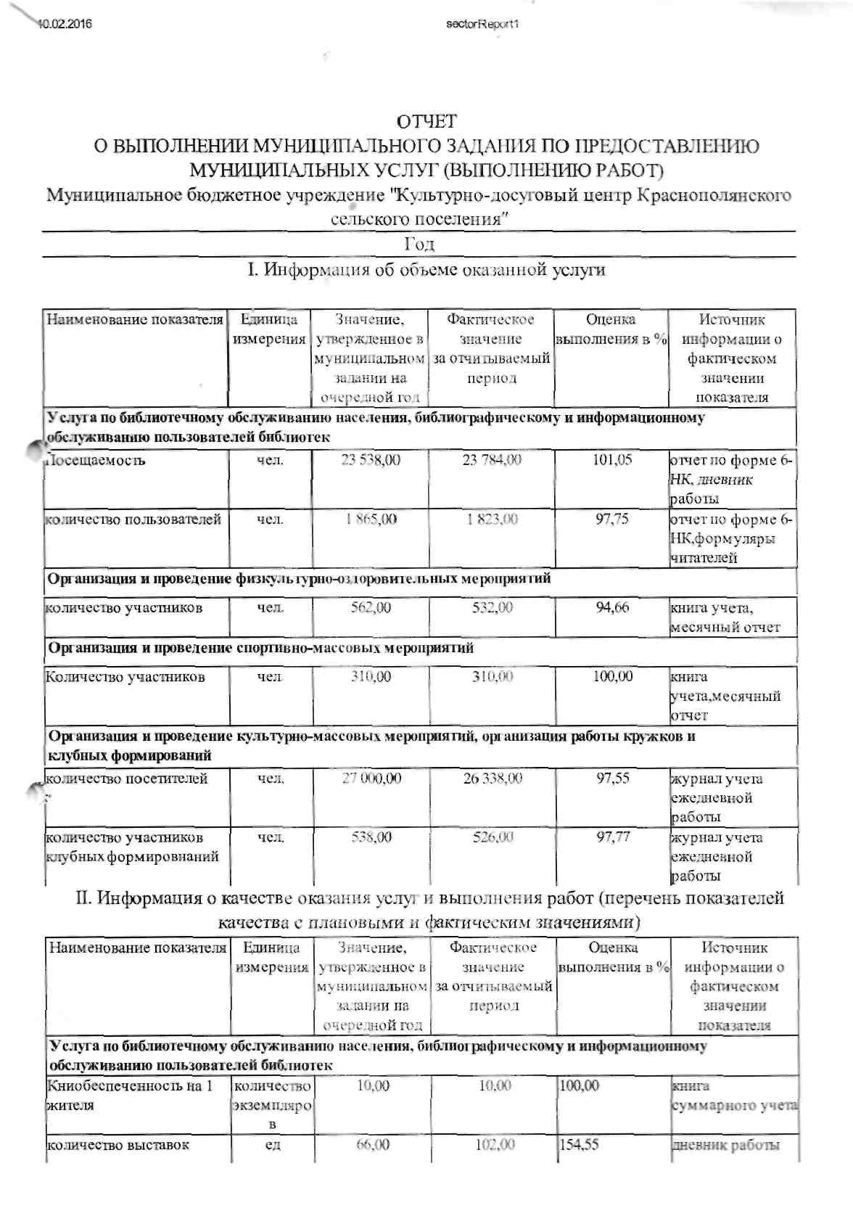
httpi/ApOStok-nposapfirjiVSector/Reports/RepatVie^^ .

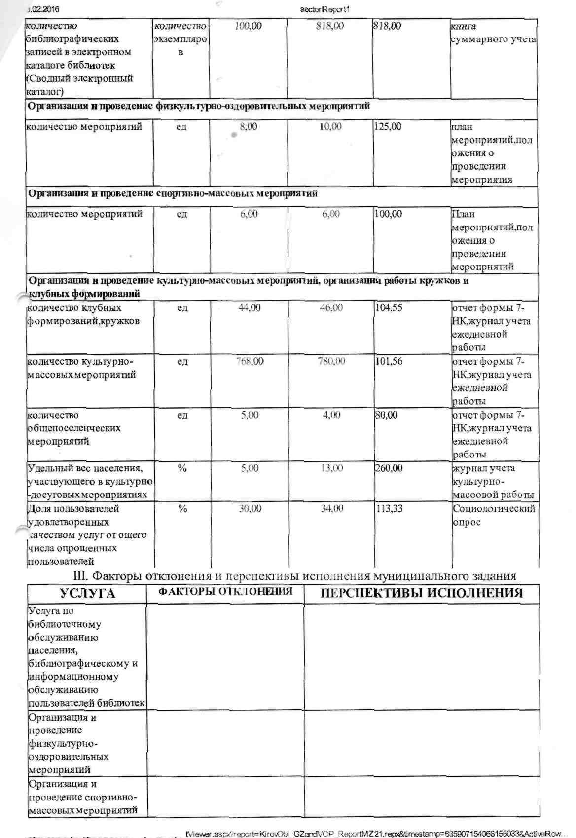
http://\^c&nposapfirjufSector/Repw^Re^ 2/3

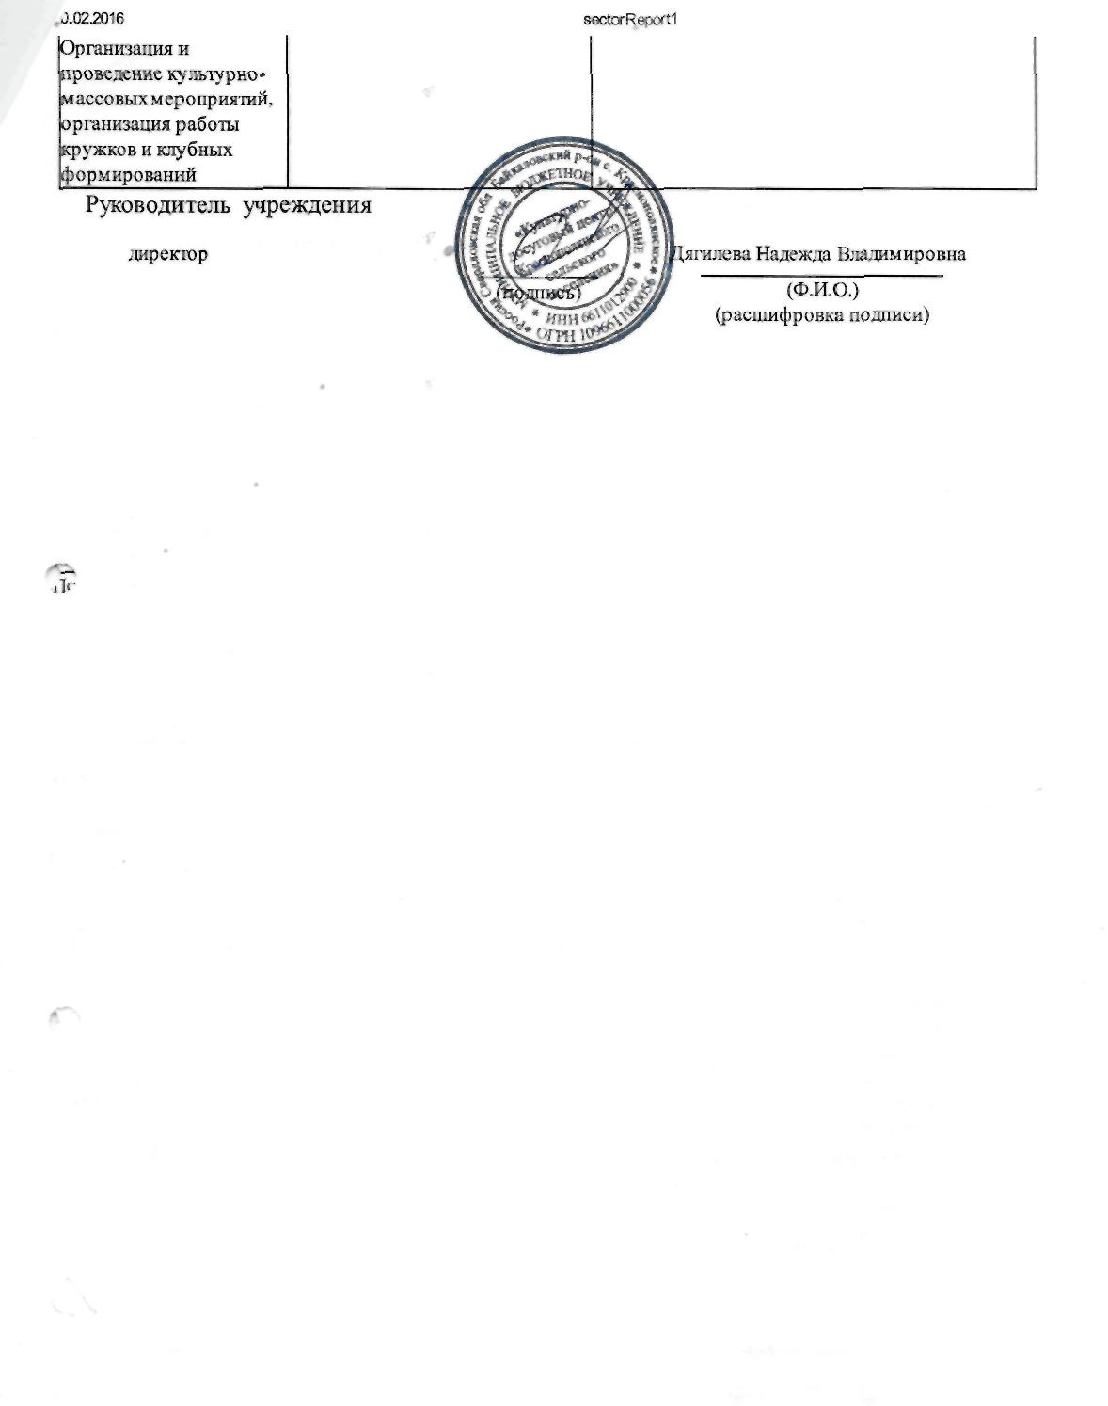
http://vostoknposapfirxu/Sect<WReports/ReportViev\^

